SQUID PROXY

* TASK 1:
* **Installation and Basic Configuration (Easy):**

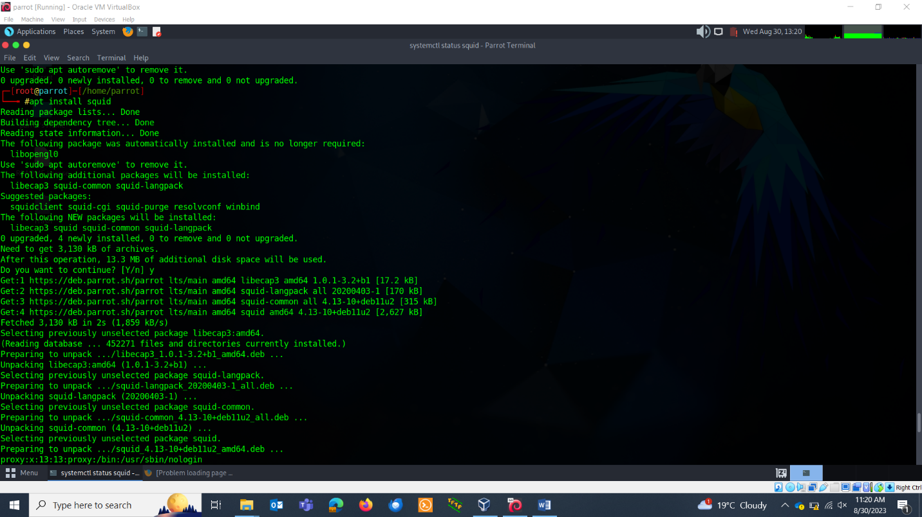

Check the status:

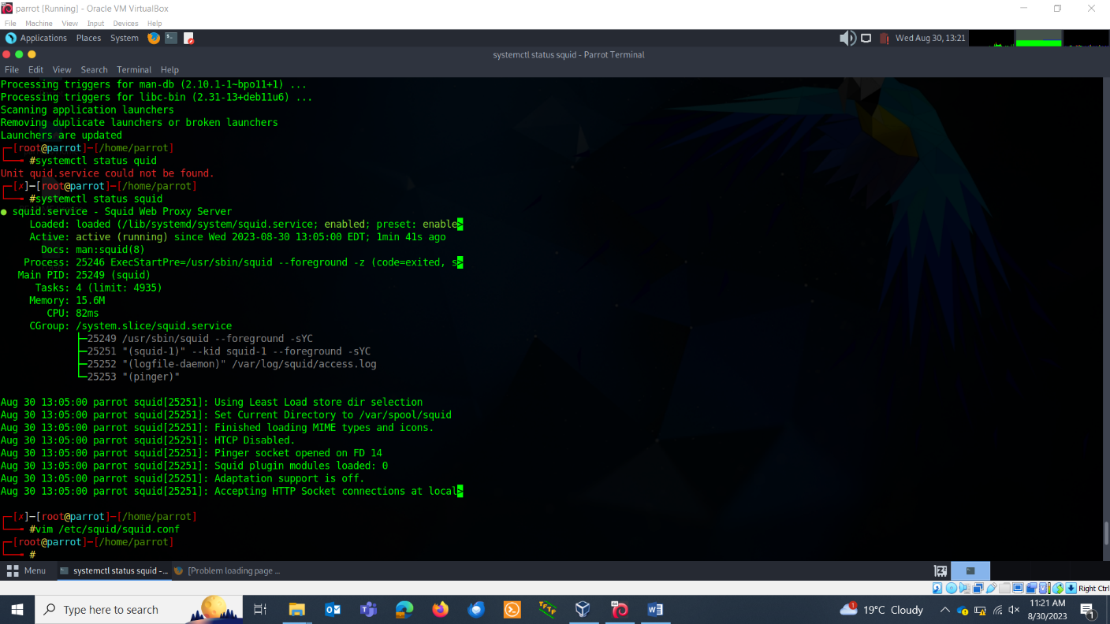

Lets go into configuration file and make some changes:



Make the following additions. Save the buffer at the end with :wq

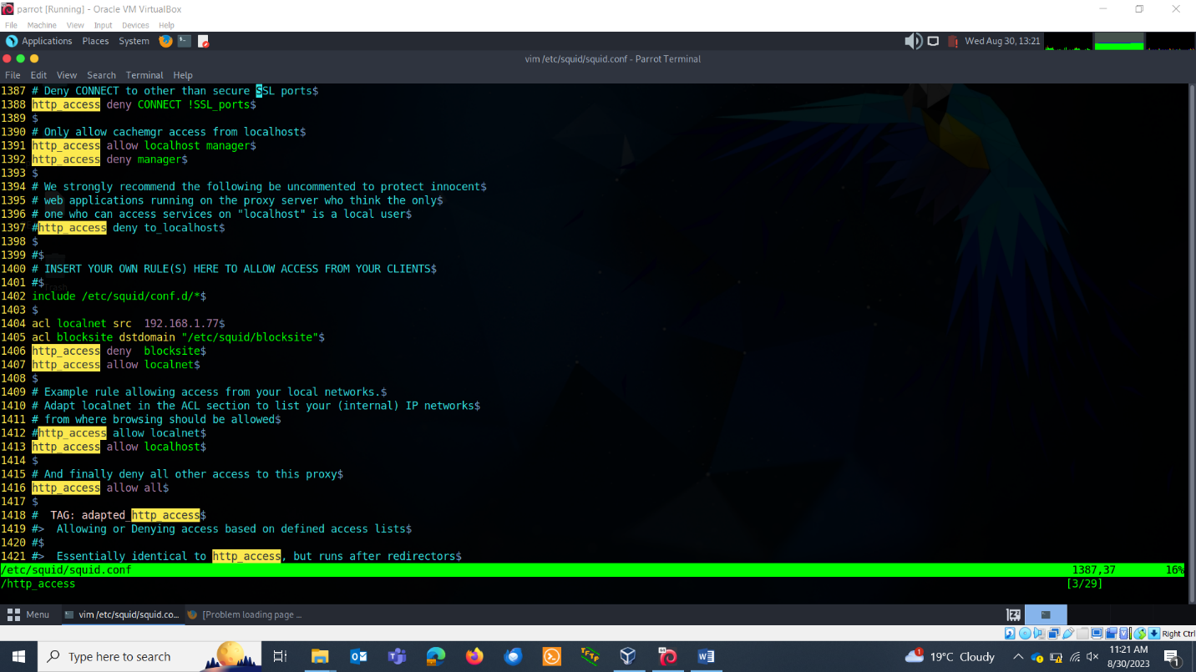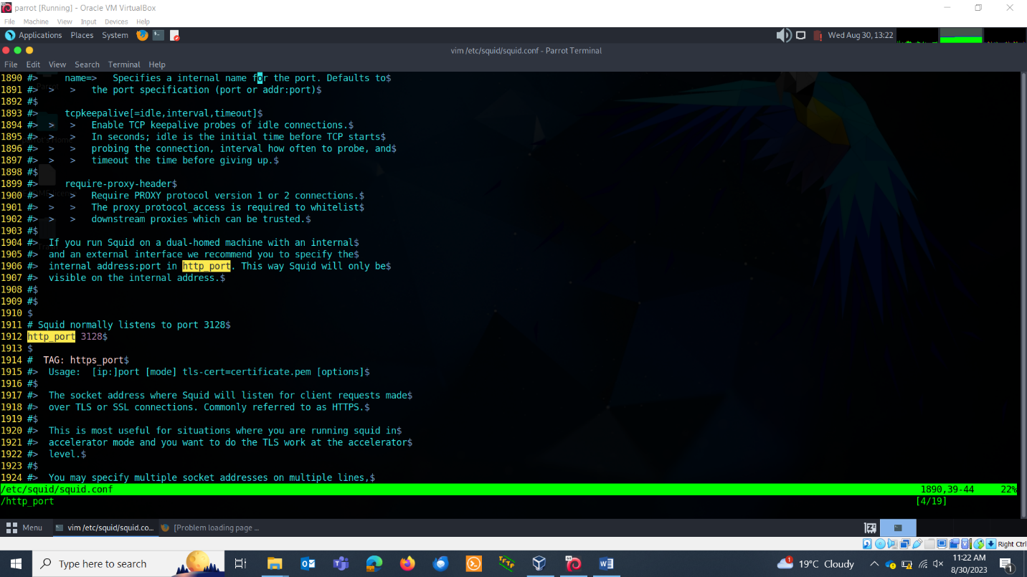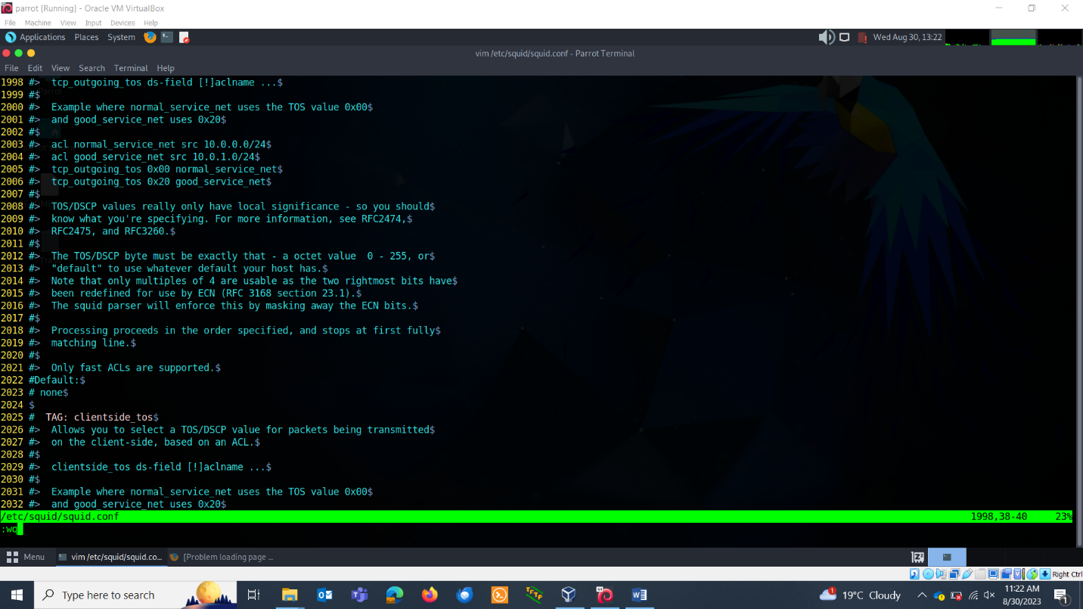

**TASK 2: Access Control**

* Configure access control rules in Squid. Set up rules to allow or deny access to specific websites or IP addresses. Block facebook.com

exit it with :wqGo to the browser. Search proxy and make the following changes.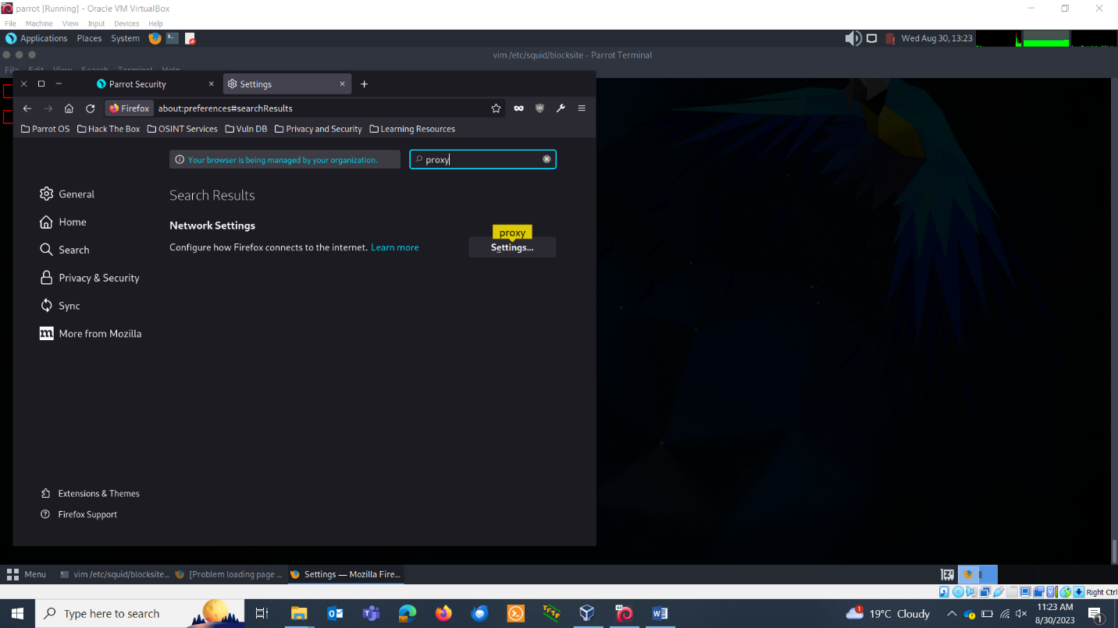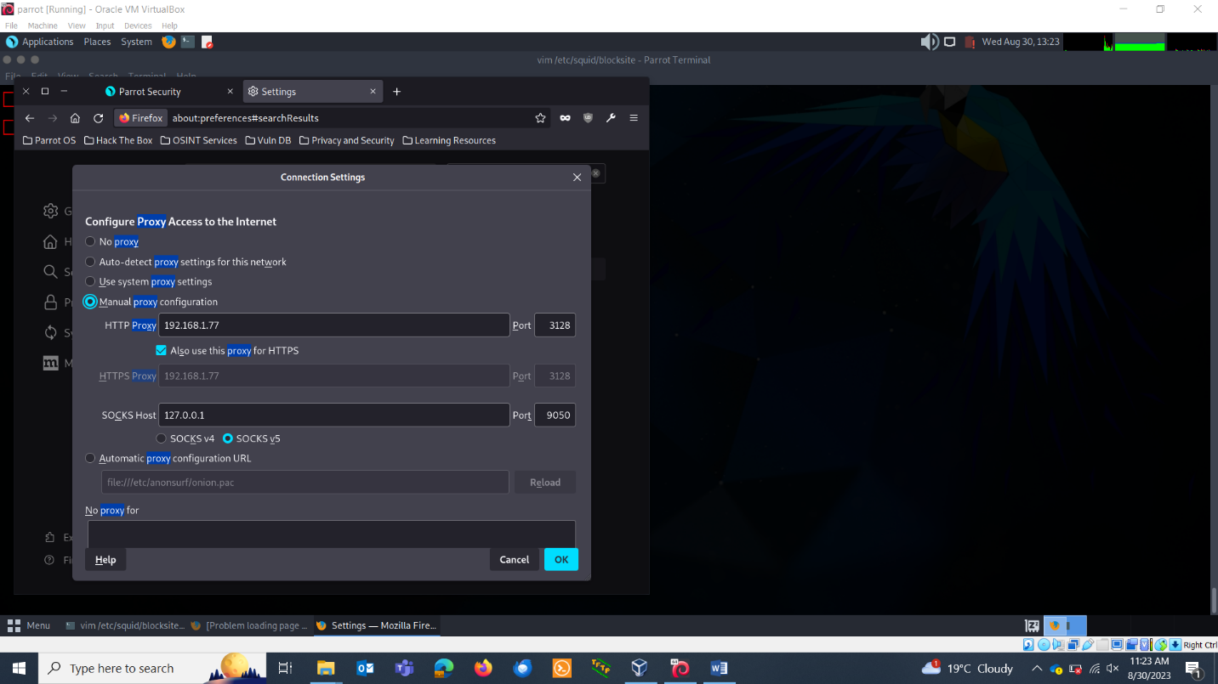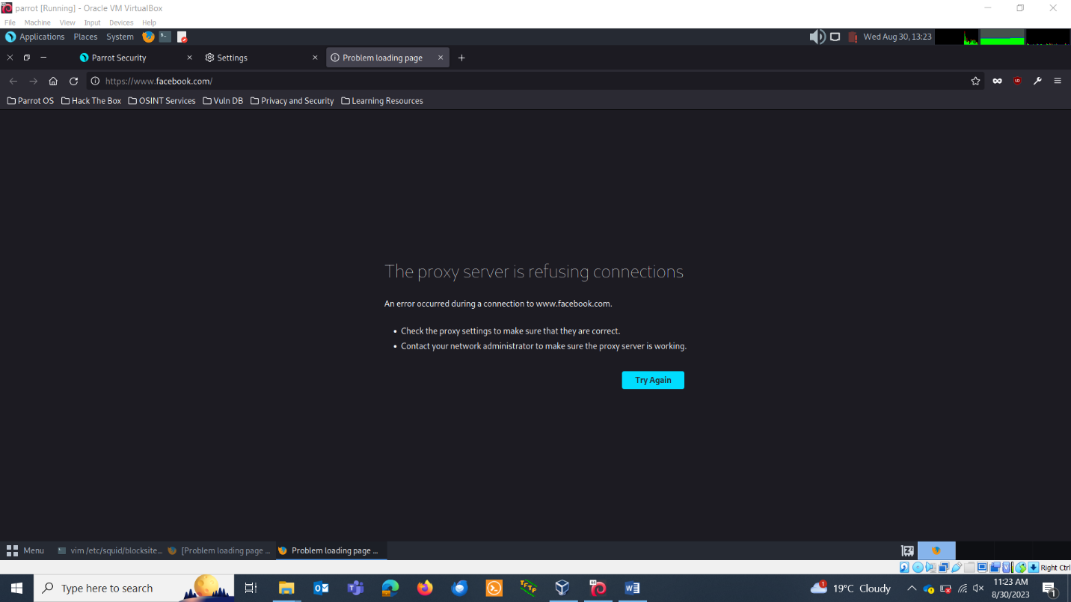

Connect other. I am connecting my ubuntu. Bring it under the same network.

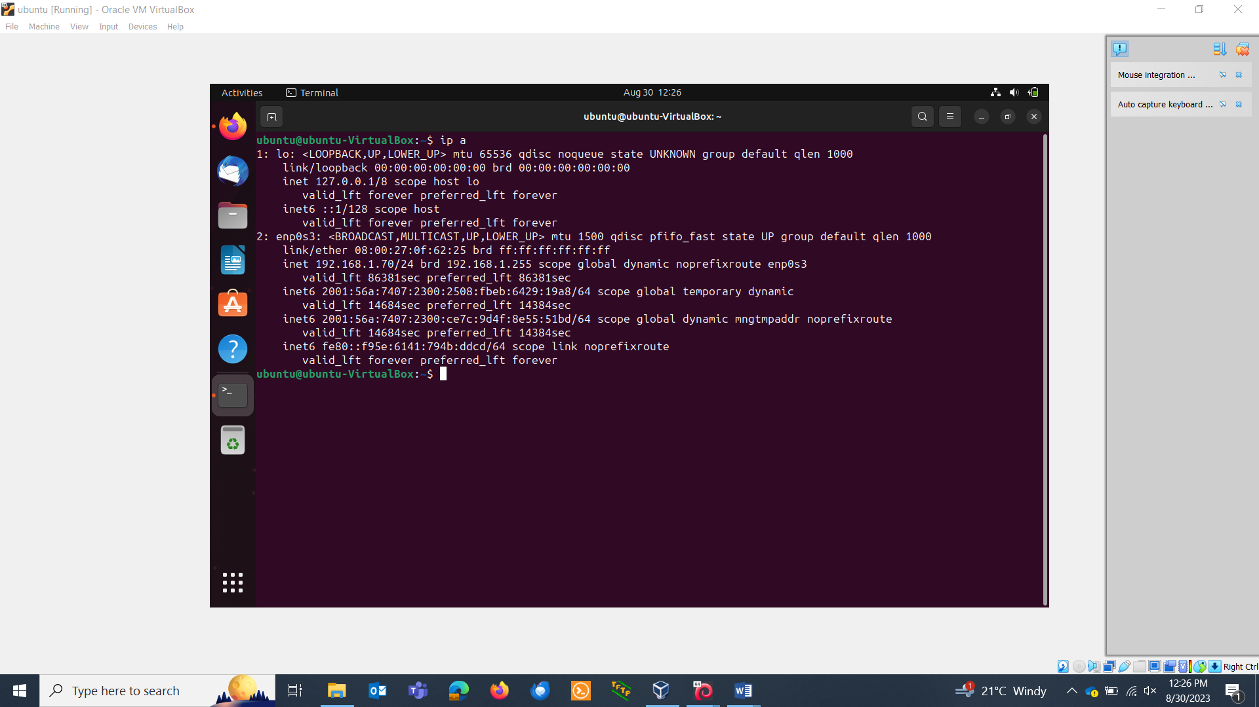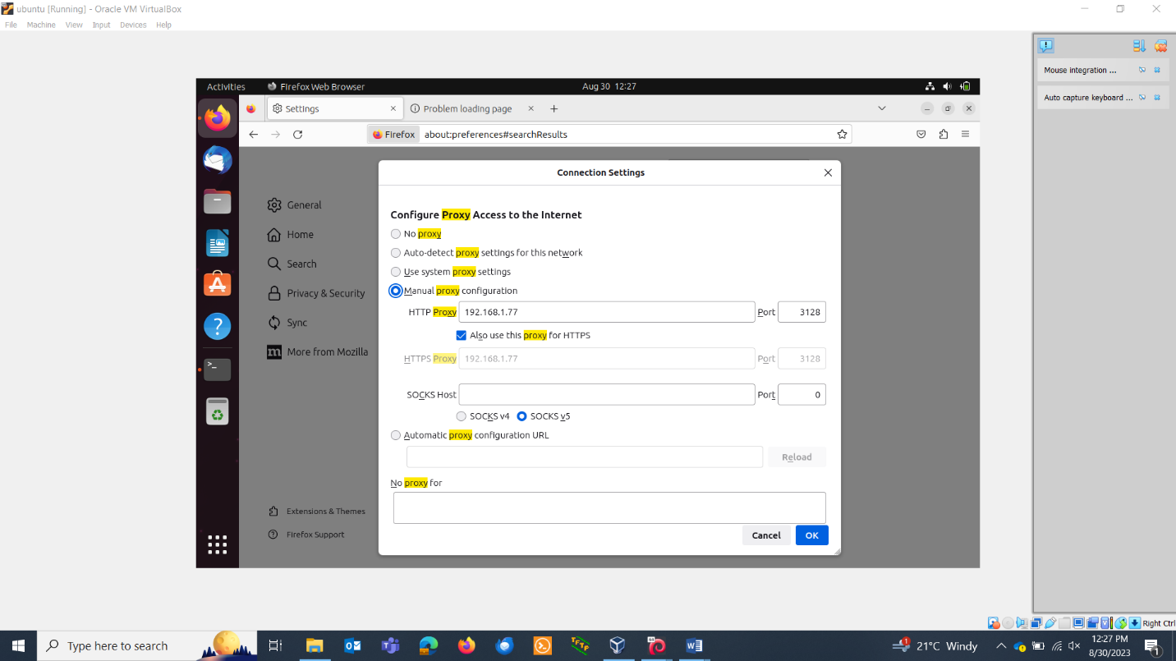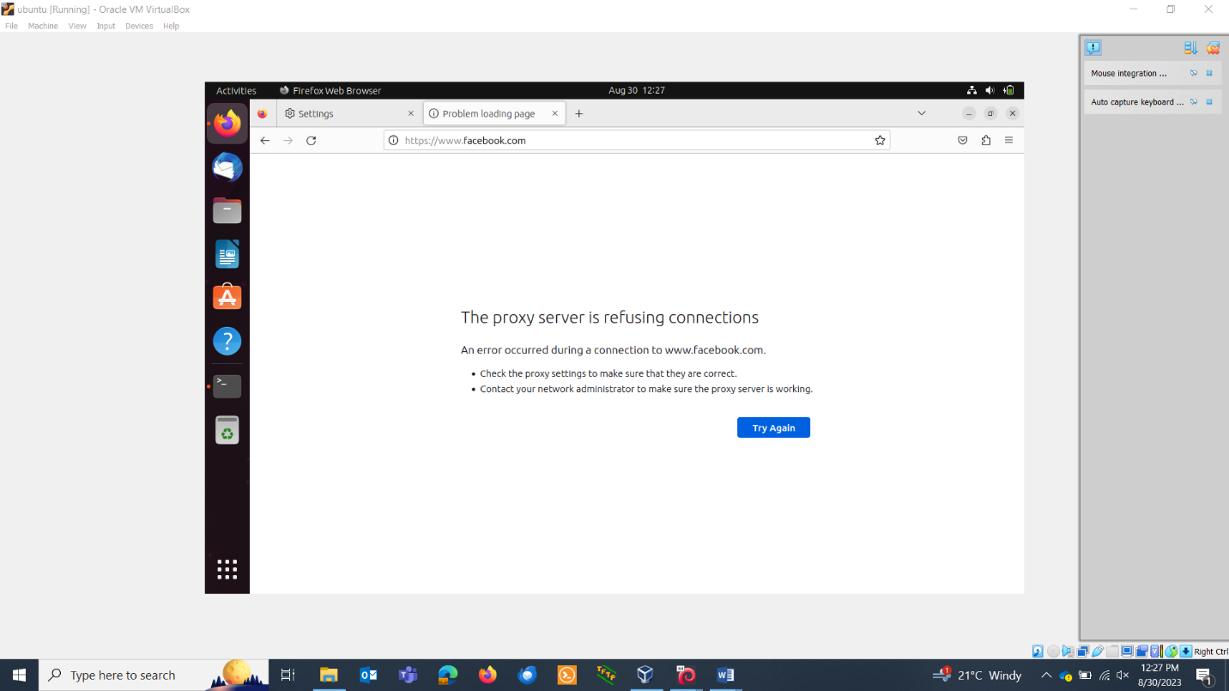

**TASK 3: LOGGING AND MONITORING**

You can access your logs here:

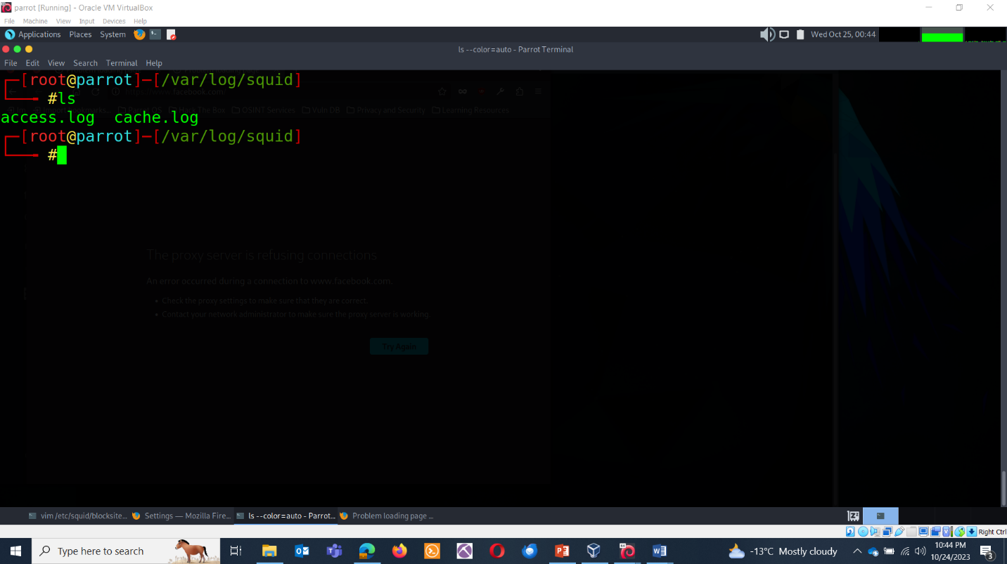

**Configure Access Controls:** To log all accesses, you can set your Squid to have an 'all' ACL (Access Control List). Add the following to your Squid configuration.

**Add following in the configuration file:**

acl all src all

http_access allow all

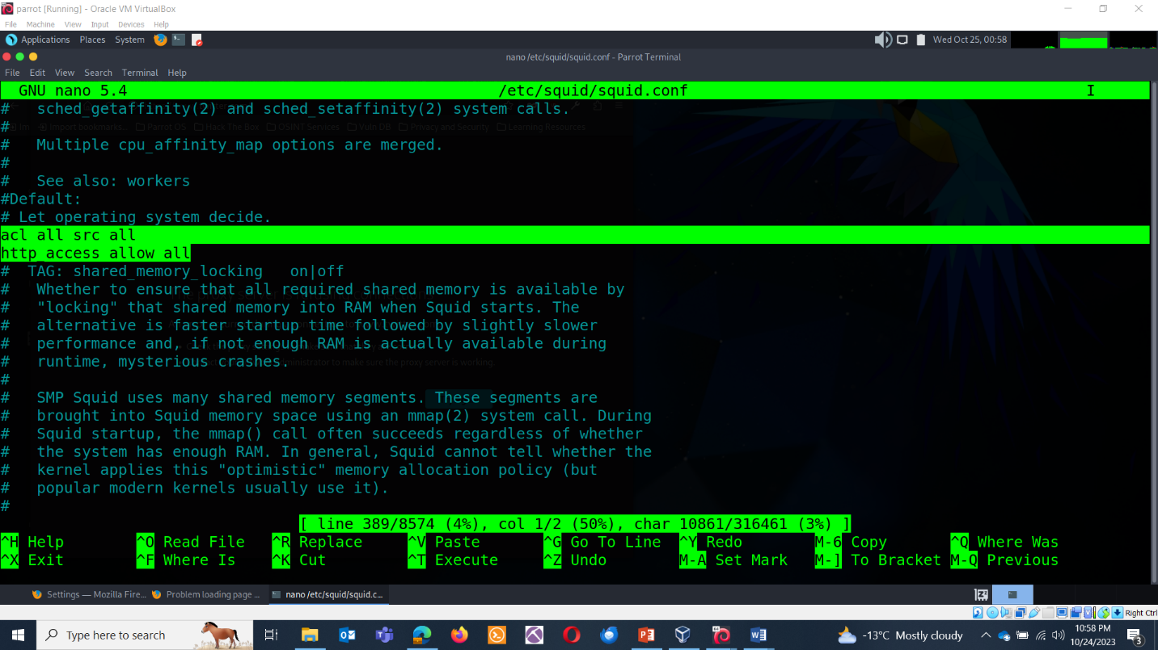

**Restart Squid:**

After making changes to the Squid configuration, restart the Squid service to apply the settings.

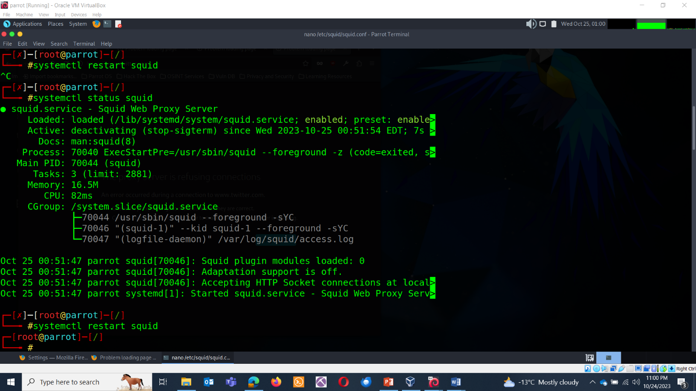

**Block a site:**

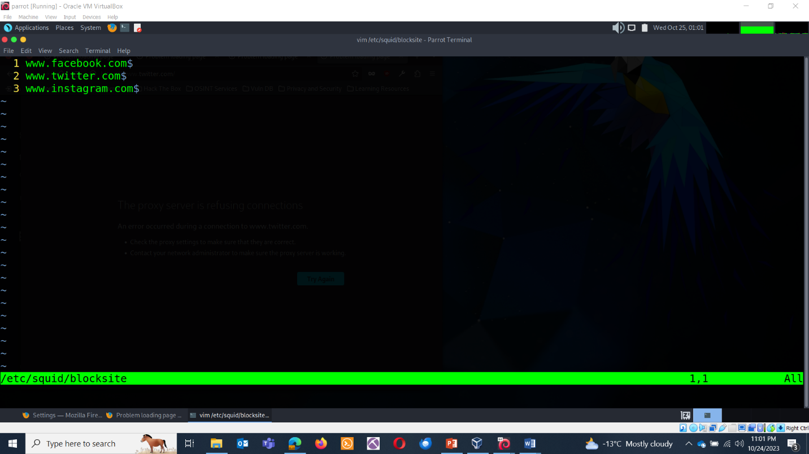

**Access the Internet:**

Use your web browser to access various websites while your Squid proxy is active. This will generate log data.

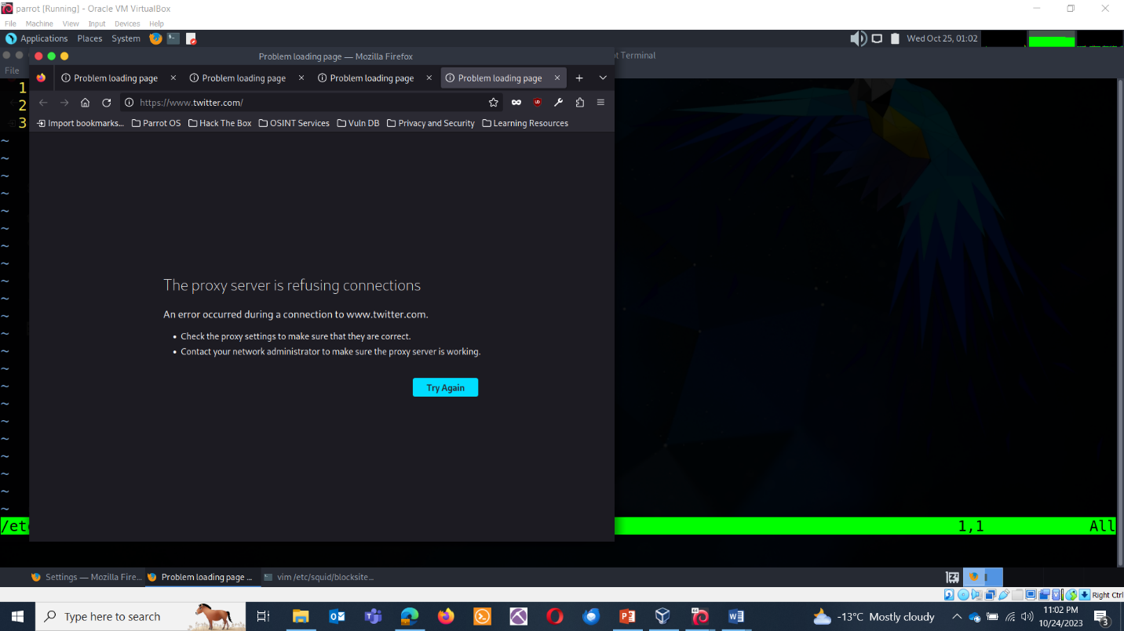

**Review Squid Access Logs:**

Use the tail command to monitor the Squid access log in real-time. Open your terminal and execute:

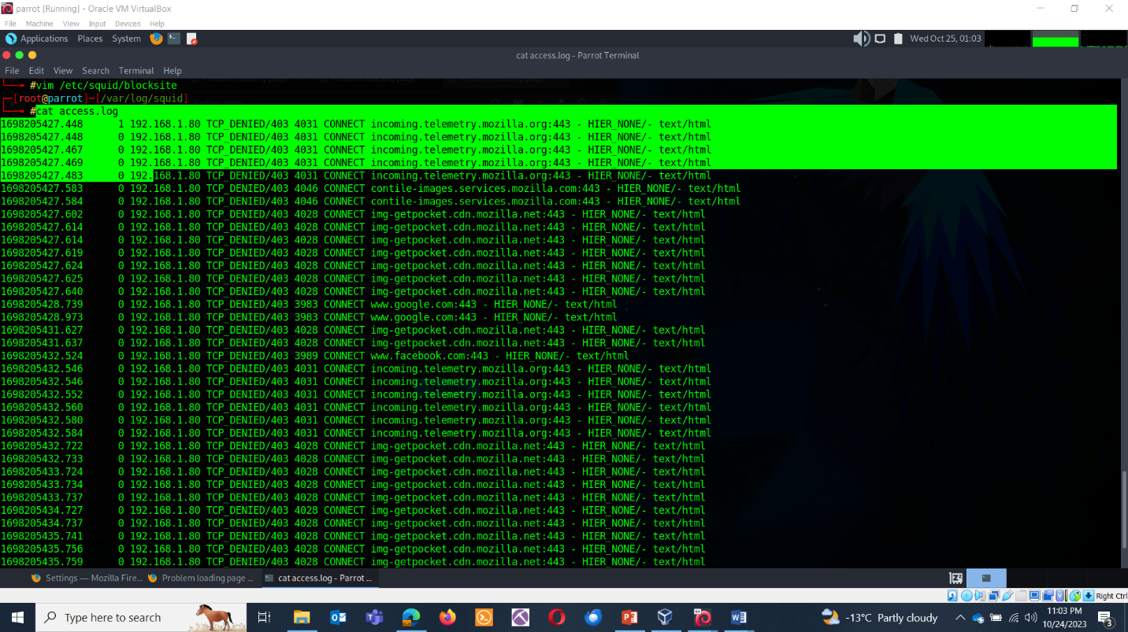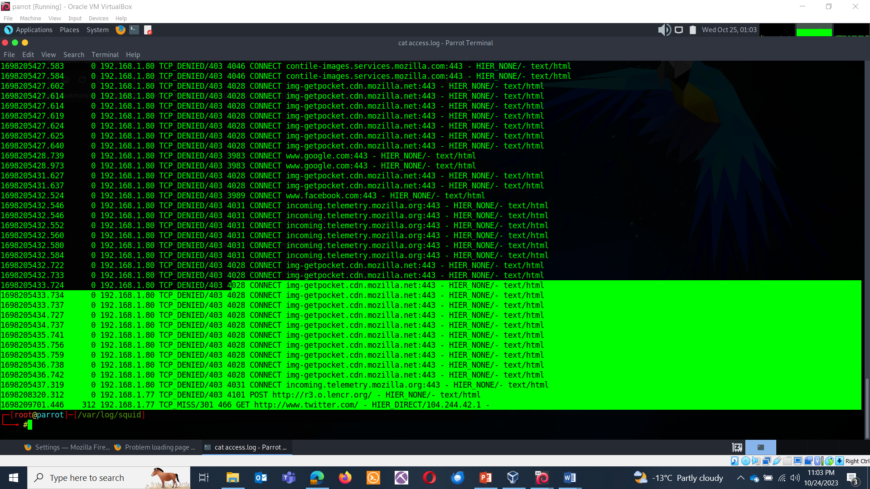

Accessing another page:

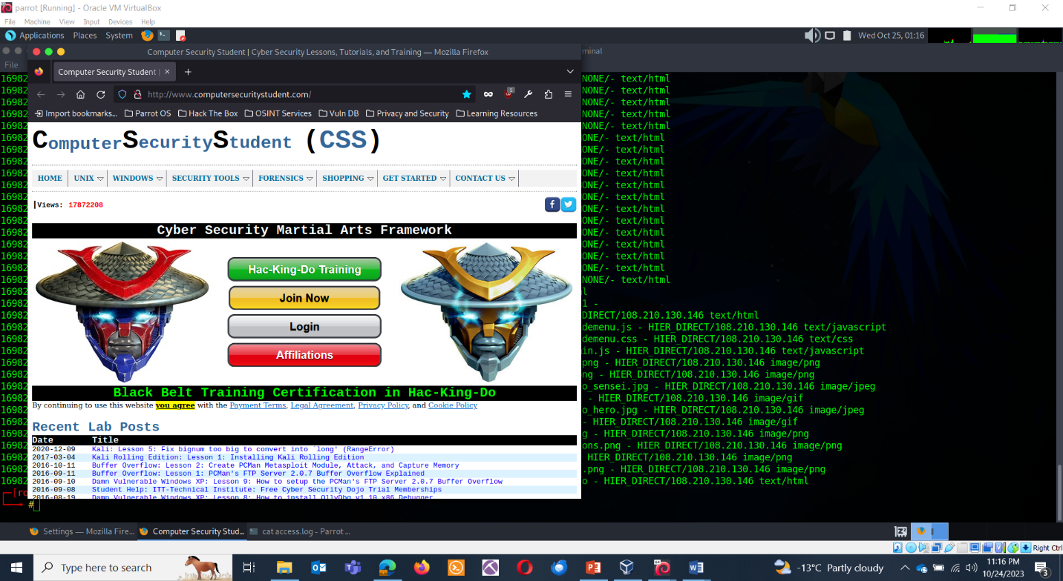

Checking logs:

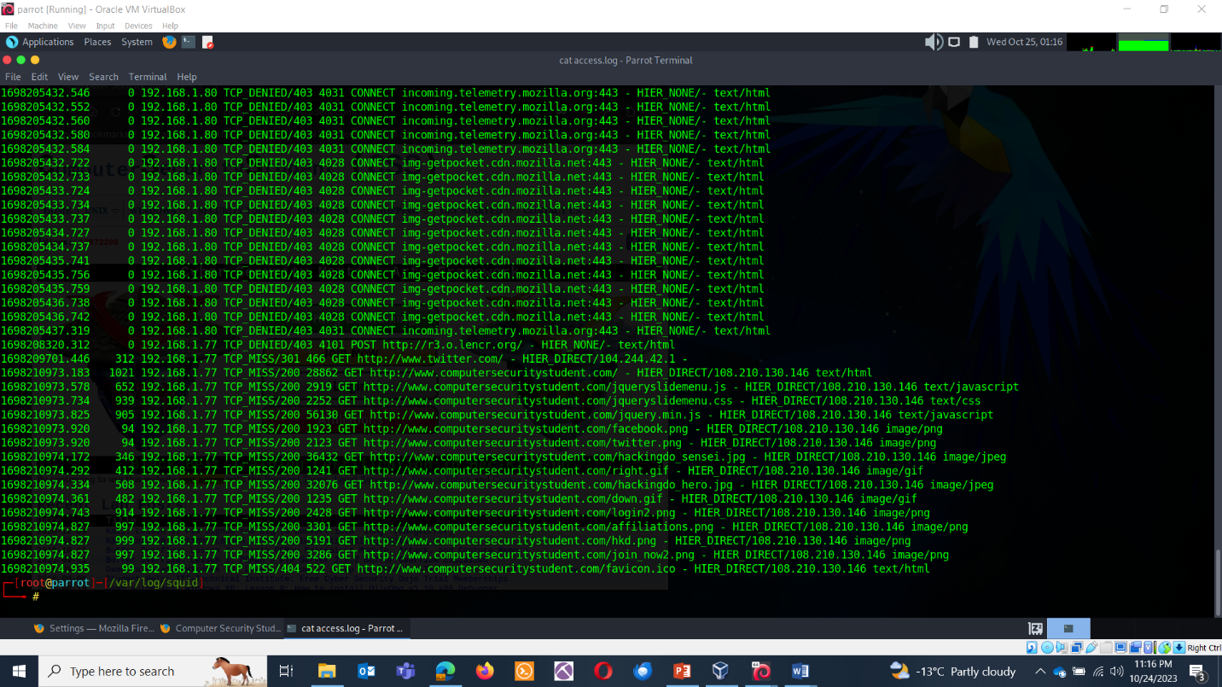

**TASK 4 : CACHING & CONTENT DELIVERY**

**CACHING** : Caching is a powerful technique that reduces the load on web servers and accelerates content delivery. You will set up caching rules, define cache storage parameters, and measure the impact on web page load times using the Apache Benchmark tool (ab).

**Set Up Caching Rules**: Open the Squid configuration file (typically located at /etc/squid/squid.conf) and define caching rules. You can set rules based on file types, websites, or specific URLs. For example, to cache all image files, **add:**

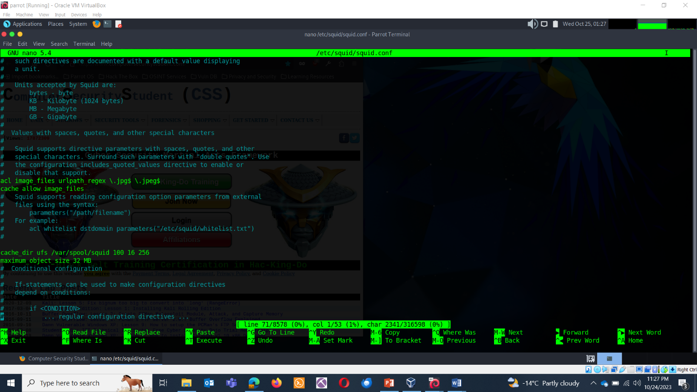

**Define Cache Storage Parameters:** Specify cache storage parameters like the cache directory, cache size, and cache replacement policies in the Squid configuration. For instance**:**

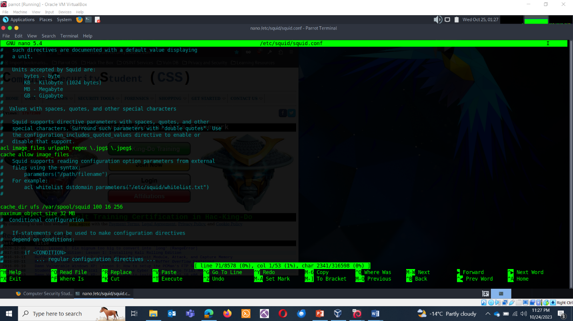

**Restart Squid**

**Systemctl restart squid**

**Benchmark Page Load Times:** Use Apache Benchmark (ab) to measure web page load times before and after enabling caching. Run commands like:

**Please observer before and after :**

*ab -n 100* [*http://example.com/*](http://example.com/)

**Before:**

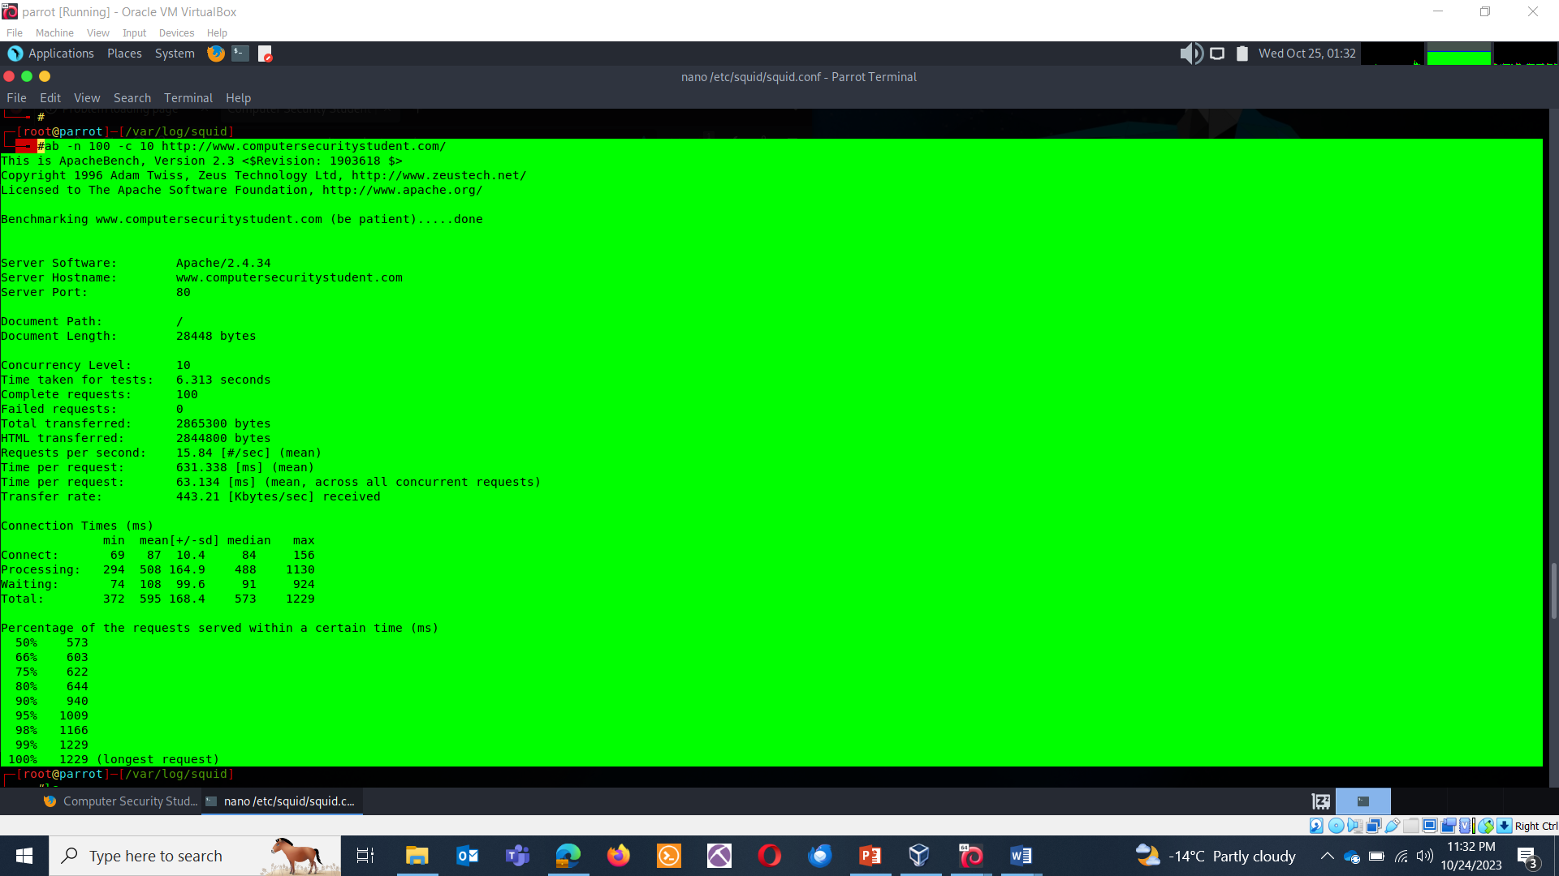

**After:**

